CST8116 Assignment 04 (21W) Sample Solution

© 2021 Algonquin College, all rights reserved.

# Screen Shot Corrected Program

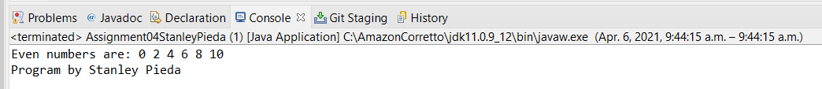

# Screen Shot Git History

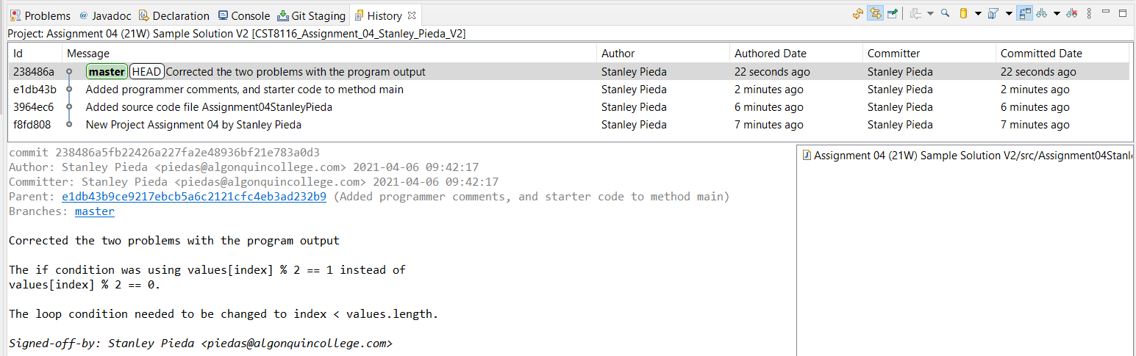

* Version 2 of the sample solution fixes both bugs with the starter code.